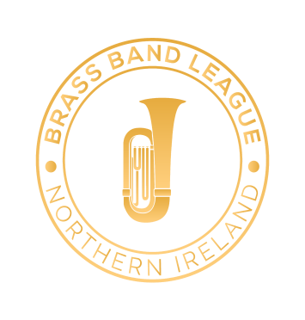

Solo & Ensemble Competition 2022

INFORMATION AND RULES – YOUTH SECTIONS

ONLINE

CLOSING DATE FOR ENTRIES
Saturday 12th February 2022

YOUTH SECTION
17 and Under Solo | Own Choice
15 and Under Solo | Selected Book
12 and Under Solo | Selected Book
10 and Under Solo | Selected Book
17 and Under Ensemble  Up to 12 players | Own Choice
12 and Under Ensemble  Up to 12 players | Own Choice
Youth Band (players aged 18 and under) | Own Choice

Note: Players aged 17 and Under may enter ONE SOLO CLASS ONLY in the Youth Section, BUT MAY ALSO enter the A or C or 19 and Under solo class and the Slow Melody class in the Senior Section.

All competitors are permitted to play only one piece.

YOUTH SOLOS - SELECTED BOOKS
10, 12 and 15 and Under Solo
The Young Soloist Volume One
Publisher: Studio Music
The Young Soloist Volume Two
Publisher: Studio Music
The Young Soloist Volume Three
Publisher: Studio Music
Winner Scores All (Peter Lawrance)
Publisher: Brass Wind
15 and Under Solo only
Great Winners (Peter Lawrance)
Publisher: Brass Wind

Please also note the following:

- Entries must be received by the 12th February 2022.

- Entry by Google Forms – https://forms.gle/nZVqsGeNBC6wWafT6
- With regards to the entry form please ensure that you double-check names are spelt correctly and that players are eligible to compete in the selected class. Please check thoroughly before submitting the entry.

- Proof of age may be requested. Competitors must have been within the age limit on the 1st February 2022.

- All competitors in the 10, 12, 15 and Under solo classes must use the books specified in the syllabus. Repeats are optional.

- Audio editing or enhancements (including reverb and multi-tracking) are not permitted
- Previously published videos cannot be used.

- Submissions can be either accompanied or unaccompanied - if accompanied these can be via any means provided social distancing guidelines are adhered to.

- Limit of 1 entry per soloist.
- All competitors are required to obtain parental/guardian/carer consent before placing any entry to the contest.
- Youth players may not play down in an age class but may play up in any age classes if they so desire.

- Entries open to everyone residing on the island of Ireland.
- In sections where age is relevant, proof of age must be provided, and competitors must have been within the age limit on the 1st February 2022.

- BBL reserve the right to withhold/amend/delete any submission if deemed appropriate to do so by them.

- Adjudicators’ decisions are final, each participant will receive their adjudicators remarks and a certificate for taking part.
- The BBL would like to highlight that percussion players are also welcome within any of the appropriate classes.

Payment options:
There are no fees for entering the contest but bands and individuals are welcome to send a donation by bank transfer (BRASS BAND LEAGUE, Sort Code: 09-01-29, Account Number: 20861074, Reference: Band Name/Individual Name) or cheque (made payable to Brass Band League NI).

In order to allow inspection and any necessary repairs to be carried out, ALL PERPETUAL TROPHIES must be returned to a member of the BBL Executive on or before 1st February 2022. It is the responsibility of the band holding any of the trophies to ensure that they are returned in a timely manner.

YOUTH SECTION ADJUDICATOR
Gael Haslett

All correspondence/payments to:
Amber MacLennan
33c Albert Road, Carrickfergus, BT38 8AD
Email: secretary@brassbandleague.org
Phone: 07593 016905

DATES TO NOTE

SPRING FESTIVAL 2022
Saturday 9th April
The Strule Arts Theatre, Omagh

