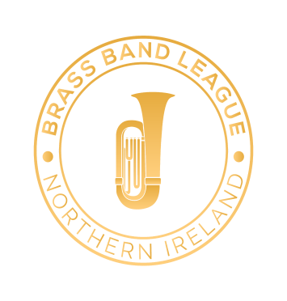

Solo & Ensemble Competition 2022

INFORMATION AND RULES – SENIOR SECTIONS

Malone Presbyterian Church Halls
Lisburn Road, Belfast

Saturday 12th February 2022

CLOSING DATE FOR ENTRIES
Saturday 29th January 2022

Entries will be accepted for one week after this date with payment of a double entry fee.
It will be at the discretion of the Brass Band League Executive Committee as to whether any entries received after this date will be accepted.
SENIOR SECTION

A Solo (Open Technical Class)  Time limit not exceeding 12½ minutes | Own Choice | £4.00
B Solo (Technical Class)  Time limit not exceeding 12½ minutes  Restricted to players aged 20 and over | Own Choice | £4.00
C Solo (Technical Class)  Time limit not exceeding 12½ minutes  Restricted to players from the 3rd section and below | Own Choice | £4.00
19 and Under Solos (Technical Class)  For players Grade 5 standard and above | Own Choice | £4.00
Slow Melody (Open) | Own Choice | £4.00
Quartet (Open)  Prize for 1st place and then prize for the highest placed quartet in each band section (Championship, 2nd, 3rd, 4th, 5th and Unaffiliated) | Own Choice | £6.00
Senior Ensemble (Open)  2-10 players, excluding quartets  Prize for 1st place and then prize for the highest placed ensemble in each band section (Championship, 2nd, 3rd, 4th, 5th and Unaffiliated) | Own Choice | £6.00

Competitors in the Ensembles class may play in a duet or trio and one other larger ensemble (five to ten players)

Solo competitors may only enter ONE of the technical classes AND the Slow Melody class.

All competitors are permitted to play only one piece.

Please also note the following:
- In order to reduce processing effort and possibility of error, the preferred method of submitting entries is via the supplied Microsoft Excel spreadsheet. If Excel is not available, a google sheet can be provided on request which can be used on PCs and mobile phones without requiring additional software. A paper entry may only be submitted using the supplied form (BLOCK CAPITALS PLEASE) if other options have been exhausted.

- Entries must be received by the 29th January 2022.

- Late entries will be accepted between 29th January and 5th February with payment of a double entry fee.

- With regards to the entry form please ensure that you double-check names are spelt correctly and that players are eligible to compete in the selected class. Please check thoroughly before submitting the entry.

- Entries will be accepted from unaffiliated bands and individuals at a double entry fee.

- The BBL will not provide an accompanist for soloists. To assist bands, a list of suggested accompanists is available on the BBL website. It is the responsibility of each performer to engage their own accompanist.

- The BBL would like to highlight that percussion players are also welcome within any of the appropriate classes.

COVID-19 safety measures
(please note that this is not an exhaustive list and we will let you know of any additional measures closer to the contest date).
- It is strongly advised that all competitors complete a lateral flow test prior to attending the contest

- Masks are to be worn when entering and exiting the building and whilst moving between rooms.

- There will be no audience for the event other than the adjudicator and contest officials. The event will hopefully be live streamed (details to be released closer to the event).

- To try and reduce movement and time taken between performances, bands will be “bubbled”. This means that if there are multiple competitors from a band they will play one after another. The order in which bands play will still be randomised along with the order of the players from each band. If your band members are using different accompanists, please let us know.

- The performances will be taking place in the ‘’Main Hall’ (the room usually used for the Youth Classes).

In order to allow inspection and any necessary repairs to be carried out, ALL PERPETUAL TROPHIES must be returned to a member of the BBL Executive on or before 1st February 2022. It is the responsibility of the band holding any of the trophies to ensure that they are returned in a timely manner.

SENIOR SECTION ADJUDICATOR
Dewi Griffiths

All correspondence/payments to:
Amber MacLennan
33c Albert Road, Carrickfergus, BT38 8AD
Email: secretary@brassbandleague.org
Phone: 07593 016905

DATES TO NOTE

SPRING FESTIVAL 2022
Saturday 9th April
The Strule Arts Theatre, Omagh

